FREIGHT FORWARDERS INFO DATABASE

A Freight forwarder Database has been requested to support:
- Contact Management,
- Freight Cost comparison,
- Decision-making on whether a purchase will be made,
- Decision-making on port of embarkation.

To maintain a proper Freight Forwarder Info Database, the following entities need to be registered among others:
- Freight Forwarder,
- Order Vendor (VIP TABLE)
- Supplier (VIP TABLE)
- Country (VIP TABLE),
- Region (VIP TABLE),
- Currencies,
- Load Types,
- Port of Loading,
- Shipping Line,
- Routes,
- Routes By Shipping Agents,
- Ocean Freight charges (Full Container / LCL),
- Ocean Freight Charge Types
- Inland Freight charges,
- Inland Freight Charge Types,
- Inland additional charges.

FREIGHT FORWARDERS
FF_CODE
FF_NAME
FF_ADDRESS_1
FF_ADDRESS_2
FF_CITY
FF_COUNTRY
FF_PHONE_1
FF_PHONE_2
FF_EMAIL
FF_CONTACT
FF_CURRENCY

CURRENCIES
CUR_CODE
CUR_DESCRIPTION
CUR_BNK_PURCHASE RATE
CUR_CUSTOMS_RATE

LOADTYPES
LT_DESCRIPTION

PORT OF LOADING
PL_CODE
PL_NAME
PL_COUNTRY

SHIPPING LINES
SA_NAME

ROUES
ROU_CODE
ROU_DESCRIPTION

ROUTES BY SHIPPING AGENTS
RSA_PORT
RSA_SHIPPING_AGENT
RSA_ROUTE
RSA_DAYS

OCEAN FREIGHT CHARGE TYPES
FCT_CODE
FCT_DESCRIPTION

INLAND FREIGHT CHARGE TYPES
IFCT_CODE
IFCT_DESCRIPTION

LCL CHARGE TYPES
LFCT_CODE
LFCT_DESCRIPTION

OCEAN FREIGHT HEADER
FQOH_FORWARDER
FQOH_QUOTENUMBER
FQOH_START_DATE
FQOH_END_DATE
FQOH_REMARKS

OCEAN FREIGHT PORT
FQOP_FORWARDER
FQOP_QUOTENUMBER
FQOP_PORT
FQOP_REMARKS
OCEAN FREIGHT PORT SLINE
FQOPL_FORWARDER
FQOPL_QUOTENUMBER
FQOPL_PORT
FQOPL_SHIPLINE
FQOPL_ROUTE
FQOPL_DAYS
FQOPL_REMARKS

OCEAN FREIGHT PORT SLINE CHARGES
FQOPLC_FORWARDER
FQOPLC_QUOTENUMBER
FQOPLC_PORT
FQOPLC_SHIPLINE
FQOPLC_CHARGE_TYPE
FQOPLC_CONTAINER_TYPE
FQOPLC_AMOUNT
FQOPLC_CURRENCY

INLAND FREIGHT HEADER
FQIH_FORWARDER
FQIH_QUOTENUMBER
FQIH_START_DATE
FQIH_END_DATE
FQIH_REMARKS

INLAND FREIGHT REGION
FQIR_FORWARDER
FQIR_QUOTENUMBER
FQIR_REGION

INLAND FREIGHT REGION TYPE
FQIRT_FORWARDER
FQIRT_QUOTENUMBER
FQIRT_REGION
FQIRT_CHARGE_TYPE
FQIRT_AMOUNT_MIN
FQIRT_AMOUNT_MAX
FQIRT_CURRENCY

INLAND FREIGHT REGION TYPE DET
FQIRTD_FORWARDER
FQIRTD_QUOTENUMBER
FQIRTD_REGION
FQIRTD_CHARGE_TYPE
FQIRTD_FROM
FQIRTD_AUTONUMBER
FQIRTD_TO
FQIRTD_PRICE
FQIRTD_PRICE_TYPE
FQIRTD_AMOUNT_MIN
FQIRTD_AMOUNT_MAX

LCL HEADER
FQLH_FORWARDER
FQLH_QUOTENUMBER
FQLH_START_DATE
FQLH_END_DATE
FQLH_REMARKS

LCL PORT
FQLP_FORWARDER
FQLP_QUOTENUMBER
FQLP_PORT
FQLP_REMARKS

LCL PORT TYPE
FQLPT_FORWARDER
FQLPT_QUOTENUMBER
FQLPT_PORT
FQLPT_CHARGE_TYPE
FQLPT_AMOUNT_MIN
FQLPT_AMOUNT_MAX
FQLPT_CURRENDY

LCL PORT TYPE DET
FQLPTD_FORWARDER
FQLPTD _QUOTENUMBER
FQLPTD _PORT
FQLPTD _CHARGE_TYPE
FQLPTD _FROM
FQLPTD _AUTONUMBER
FQLPTD _TO
FQLPTD _PRICE
FQLPTD _OVER
FQLPTD _PRICE_TYPE
FQLPTD _AMOUNT_MIN
FQLPTD _AMOUNT_MAX

INLAND ADDITIONAL CHARGES
FQIA_FORWARDER
FQIA _CHARGE_TYPE
FQIA _LOADTYPE
FQIA _AMOUNT
FQIA_ACTION
FQIA _CHARGE_OVER
FQIA _CHARGE_PER
FQIA _FROM
FQIA _TO
FQIA _AMOUNT_MIN
FQIA _AMOUNT_MAX
FQIA _CURRENCY

USER INTERFACES:
To maintain a proper Freight forwarders Database, first user interfaces need to be created to maintain the sub tables:

- CURRENCIES,
- LOADTYPES,
- PORT OF LOADING,
- SHIPPING LINES,
- SHIPPING AGENT,
- ROUTES,
- CONTAINER_SPECS,
- CONTAINER_TYPES,
- ROUTES BY SHIPPING AGENTS,
- OCEAN FREIGHT CHARGE TYPES,
- INLAND FREIGHT CHARGE TYPES,
- LCL CHARGE TYPES,
- PRICE TYPES,
- AMOUNT_TYPE,
- CHARGE ACTION,
- CHARGE_OVER,
- CHARGE_PER.

Maintenance Freight Forwarders charges:
To maintain the Freight Forwarders charges, a Freight Forwarder must be selected from the VIP Shippers Table SHIPT.

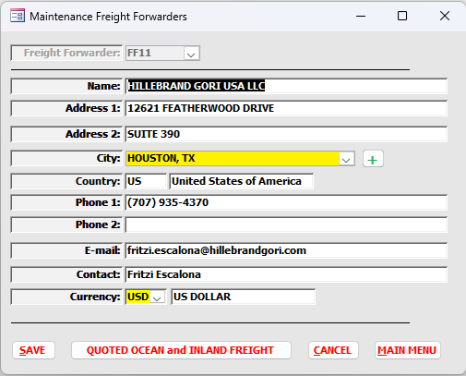
The user can update the information in the screen if necessary. After pressing the “Quoted Ocean and Inland Freight” button, the following screen will be displayed to enter the freight charges.

OCEAN FREIGHT:
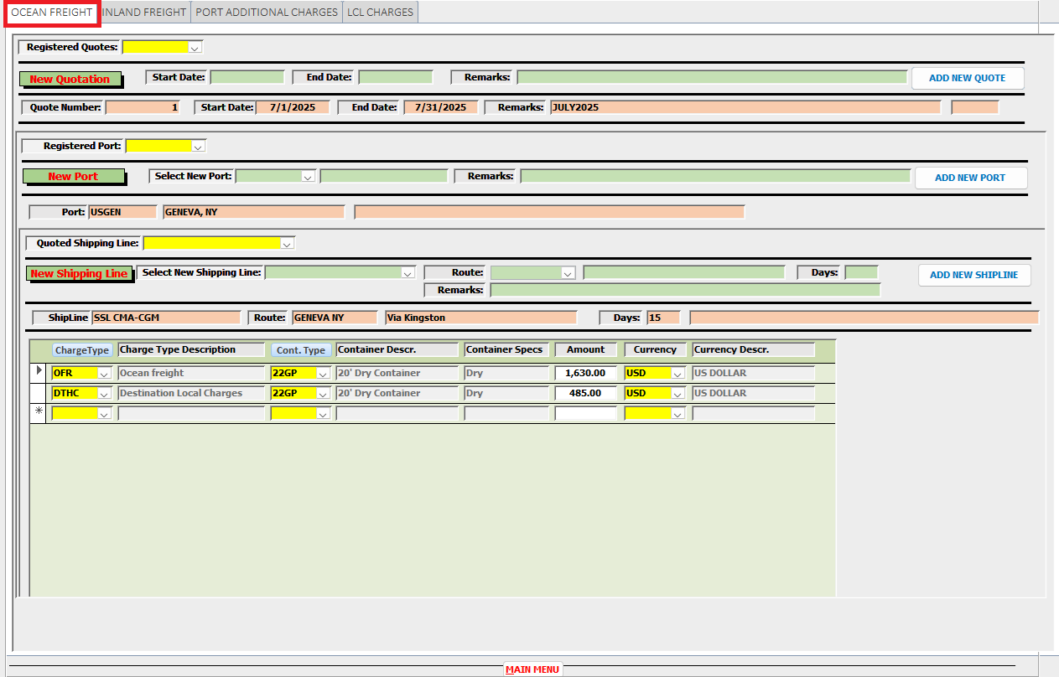
Ocean Freight Quotation Management
Registered Quotes
- Displays all existing Ocean Freight quotes in descending order.
- When a quote is selected:
  - All related fields are automatically populated.

New Quotation
To create a new Ocean Freight quote:
- Enter the following required fields:
  - Start Date
  - End Date
  - Remarks
- Click “Add New Quote”
System behavior:
- The most recently created Ocean Freight Quote and its related records are:
  - Copied
- The new quote will:
  - Use the entered Start Date, End Date, and Remarks
  - Be assigned a new, unique Quote Number

Registered Port
- Displays all ports linked to the selected quote.
- When a port is selected:
  - Related fields are automatically populated

New Port
To add a new port:
- Select a Port Code
  - The Port Name will auto-fill
- Enter Remarks
- Click “Add New Port”
System behavior:
- A new Port record is created and linked to the selected Quote

Quoted Shipping Line
- Displays existing Shipping Lines linked to:
  - The selected Quote
  - The selected Port
- When selected:
  - Related fields are automatically populated

New Shipping Line
To add a new shipping line:
- Enter/select:
  - Shipping Line
  - Route
  - Remarks
- Click “Add New ShipLine”
System behavior:
- A new Shipping Line record is created and linked to:
  - The selected Quote
  - The selected Port

Ocean Freight Charges
To register charges, provide:
- Ocean Freight Charge Type
- Container Type
- Amount
- Currency
System behavior:
- The charge is recorded and linked to the corresponding:
  - Shipping Line
  - Port
  - Quote

INLAND FREIGHT:
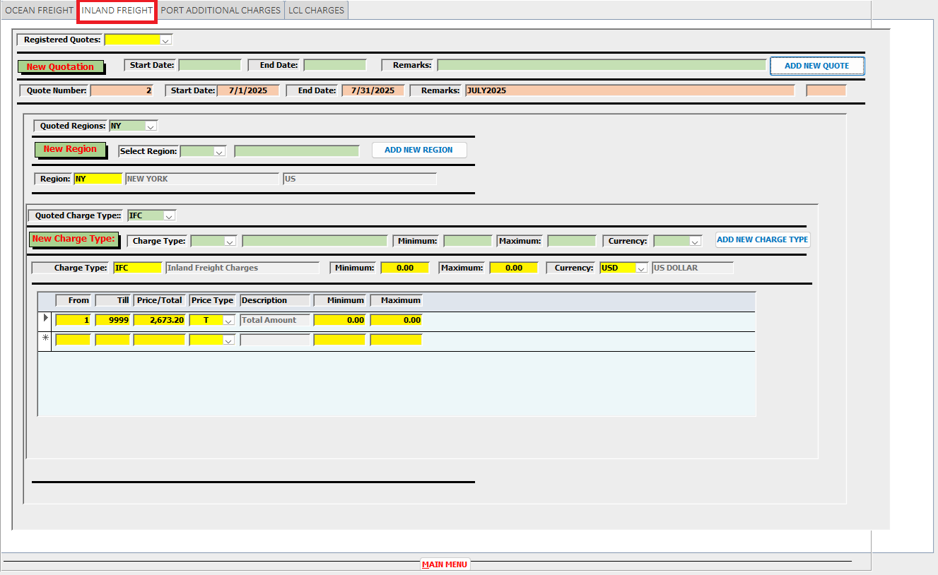

Inland Freight Quotation Management
Registered Quotes
- Displays all existing Inland Freight quotes in descending order.
- When a quote is selected:
  - All related fields are automatically populated.

New Quotation
To create a new Inland Freight quote:
- Enter the required fields:
  - Start Date
  - End Date
  - Remarks
- Click “Add New Quote”
System behavior:
- The most recently created Inland Freight Quote and its related records are:
  - Copied
- The new quote will:
  - Use the entered Start Date, End Date, and Remarks
  - Be assigned a new, unique Quote Number

Registered Regions
- Displays all Regions linked to the selected Quote.
- When a Region is selected:
  - Related fields are automatically populated

New Region
To add a new Region:
- Select a Region Code
  - The Region Name is automatically displayed
- Click “Add New Region”
System behavior:
- A new Region record is created and linked to the selected Quote

Quoted Charge Type
- Displays existing Charge Types linked to:
  - The selected Quote
  - The selected Region
- When selected:
  - Related fields are automatically populated

New Charge Type
To create a new Charge Type:
- Enter the following:
  - Charge Type (description auto-fills after selection)
  - Minimum Amount (0 is allowed)
  - Maximum Amount (0 is allowed)
  - Currency
- Click “Add New Charge Type”
System behavior:
- A new Charge Type record is created and linked to:
  - The selected Quote
  - The selected Region

Charge Type Details
After selecting or creating a Charge Type, define its pricing structure:
- Cases From
- Cases Till
- Price / Amount
- Price Type
- Minimum Amount
- Maximum Amount
System behavior:
- These details are stored as tiered pricing records linked to the selected Charge Type

LCL CHARGES:
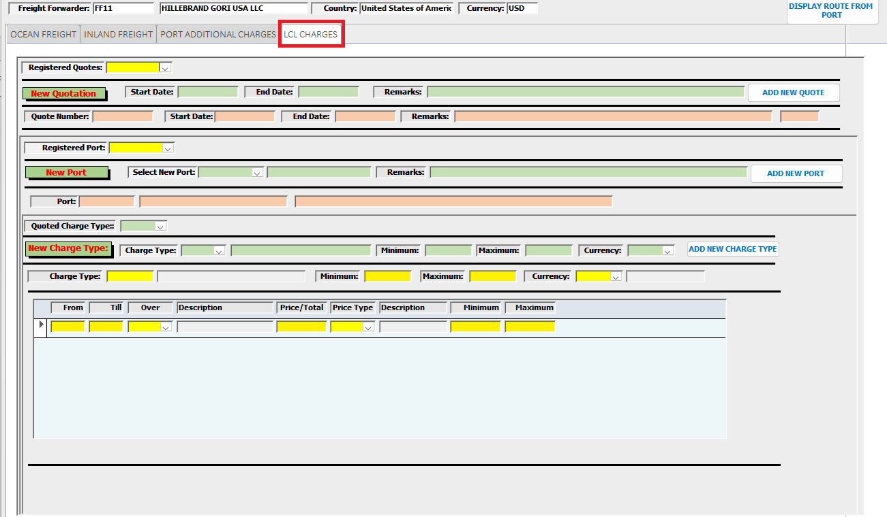

LCL Quotation Management
Registered Quotes
- Displays all existing LCL quotes in descending order.
- When a quote is selected:
  - All related fields are automatically populated.

New Quotation
To create a new LCL quote:
- Enter the required fields:
  - Start Date
  - End Date
  - Remarks
- Click “Add New Quote”
System behavior:
- The most recently created LCL Quote and its related records are:
  - Copied
- The new quote will:
  - Use the entered Start Date, End Date, and Remarks
  - Be assigned a new, unique Quote Number

Registered Port
- Displays all ports linked to the selected quote.
- When a port is selected:
  - Related fields are automatically populated

New Port
To add a new port:
- Select a Port Code
  - The Port Name will auto-fill
- Enter Remarks
- Click “Add New Port”
System behavior:
- A new Port record is created and linked to the selected Quote

Quoted Charge Type
- Displays existing Charge Types linked to:
  - The selected Quote
  - The selected Port
- When selected:
  - Related fields are automatically populated

New Charge Type
To create a new Charge Type:
- Enter the following:
  - Charge Type (description auto-fills after selection)
  - Minimum Amount (0 is allowed)
  - Maximum Amount (0 is allowed)
  - Currency
- Click “Add New Charge Type”
System behavior:
- A new Charge Type record is created and linked to:
  - The selected Quote
  - The selected Region

Charge Type Details
After selecting or creating a Charge Type, define its pricing structure:
- Cases From
- Cases Till
- Price / Amount
- Price Type
- Minimum Amount
- Maximum Amount
System behavior:
- These details are stored as tiered pricing records linked to the selected Charge Type

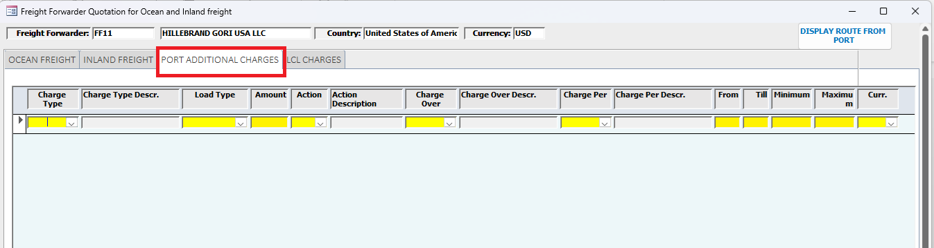

Port Additional Charges Management
If additional port charges are applicable, they must be registered by entering the required details below.
Charge Registration Fields
- Charge Type
  - Selection required
  - Description is automatically displayed after selection
- Load Type
  - Defines the applicable cargo/load category
- Amount
  - The base charge value
- Action
  - Selection required
  - Description is automatically displayed
- Charge Over
  - Selection required
  - Description is automatically displayed
- Charge Per
  - Selection required
  - Description is automatically displayed
- From
  - Start of applicable range (e.g., weight, units, or other criteria)
- Till
  - End of applicable range
- Minimum Amount
  - Lower limit of the charge (if applicable)
- Maximum Amount
  - Upper limit of the charge (if applicable)
- Currency
  - Currency in which the charge is applied

